

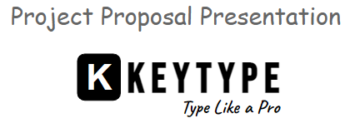

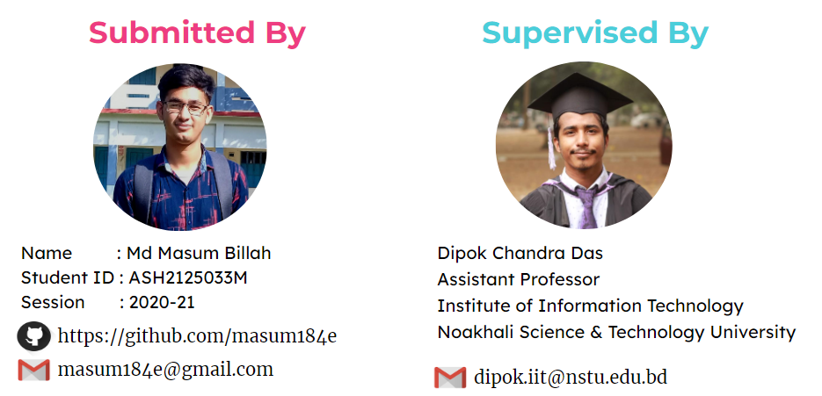

**Introduction:**

KEYTYPE is an educational typing game that will improve user's typing speed and accuracy. It will be interactive and entertaining, making it an enjoyable way to learn typing skills.

**Objectives:**

**Educational purposes:** A typing game can help people improve their typing skills and accuracy, which is an essential skill in today's world where most communication and work is done on computers.

**Entertainment:** A typing game can be a fun and engaging way to pass the time and challenge oneself. It can also be a great way to unwind after a long day.

**Stakeholders:**

* Computer Operator
* Programmer
* Student

**Project Goal:**

* Solve Real World Problem
* Boost Up Your Typing Speed
* Building Strong Grip On Key

**Software Development Life Cycle Model**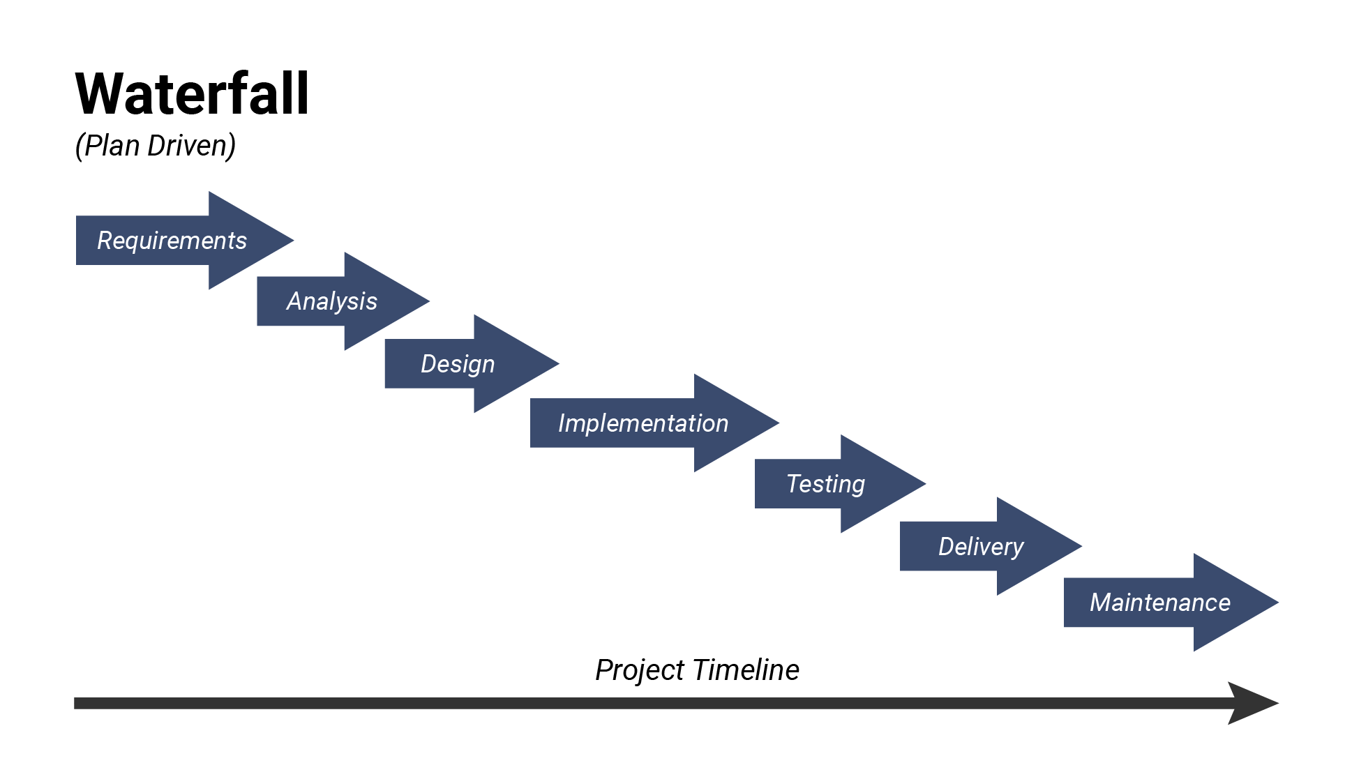

**Tools & Language:**

**JAVA:** Java is a high-level, class-based, object-oriented programming language that is designed to have as few implementation dependencies as possible.

**VS Code:** Visual Studio Code is a source-code editor made by Microsoft with the Electron Framework, for Windows, Linux and macOS.

**Project Timeline:**

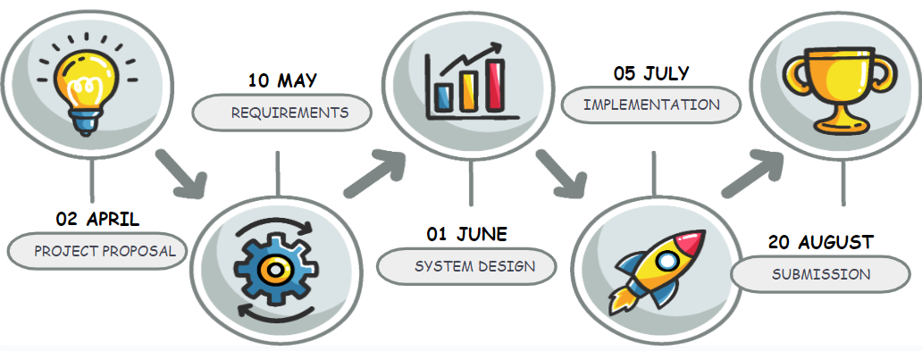

**Deliverables:**

* Source Code
* Documents
* JAR File

**Challenges:**

**User Interface:** Console games lack the graphical user interface, so you need to design and implement the game's user interface in the console. This can be challenging as you need to display information, game menus, and game states in a way that is easy to understand.

**User Input Handling:** Console games require user input to interact with the game. Handling user input can be complex, especially when you need to validate and process the user input to update the game state.

**Testing:** Testing a console game can be challenging as you need to test the game's mechanics, user interface, and performance manually. This can be time-consuming and requires attention to detail.

**Debugging:** Debugging a console game can be challenging as you need to rely on console outputs to identify errors and bugs in the game code.